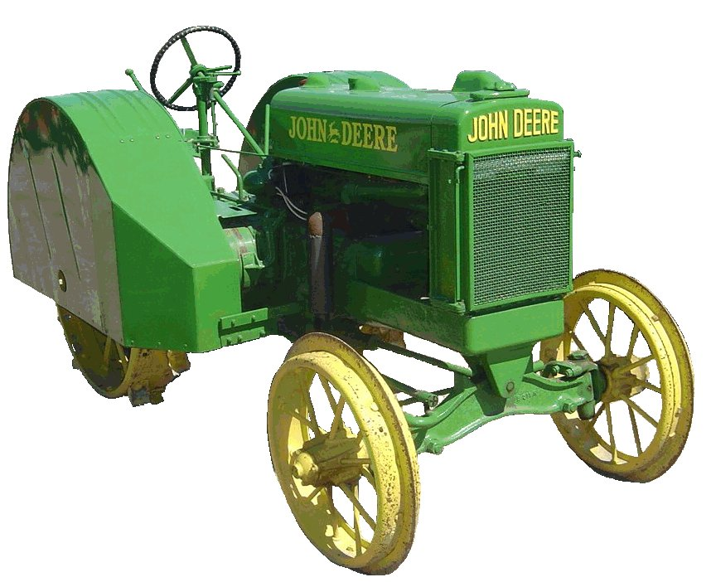
F O O T H I L L S

F O O T H I L L S

ANTIQUE POWER ASSOCIATION
ESTABLISHED 2003

August 2015
Dear Members,
I pray this finds you well and peaceful and keeping cool in the heat of this summer. Our “summer vacation” is just about over. The fall event season is almost upon us with many, many things to do and places to go. Hopefully you all will be able to enjoy as many events as possible. When you do, remember that the people there see you and what they see tells them what kind of organization we are.

--- --- --- From our August Meeting --- --- ---

- Every day we ought to pray for one another, especially for those who are in special need. Not that we are more fervent in those latter prayers, but we ought to be more diligent because when we pray for our brother or sister, we actively are members one of another (Romans 12:5) as God has made us to be in Christ – we share their sorrow and their joy and they ours as they pray for us.

  - Kelly Blanton
  - Glenn & Dot Hawn
  - Butch Minyard
  - Nancy Edgar
  - Denelda Reese
  - Gerry Stewart
  - Sheldon Smith
  - Rev. Bobby Langston
  - Allen Everdyke
  - Lorna Sheets
  - Charles Huffman
  - Steve Hefner
  - Penny Hodges
  - Justin Beach
  - Wade Hefner
  - Charles Elmore
  - Norris Turner
  - Kristie Isenhour
  - Don Johnson
  - Stewart (Ranny) Frye
  - Ned Story
  - Carl Porter
  - Jane Abernathy
  - Terry Martin
  - Jim Davis
  - Eugene Hartley
  - Charles McRee
  - Ann Cline
  - Hoyle Hoover

- In July, the Show Committee met to make the tough decisions on how to distribute the proceeds from the May show. There are many worthy organizations to which we could show our generosity, but there is only so much to distribute.
  - Over all, the proceeds from the 2015 show were just about equal to those from the 2014 show. However, there were a few extra expenses this year, particularly last minute finishes on the store building. As a result, the total disbursement is a little less than 2014.
  - The Show Committee’s recommendation was presented to the membership present at the August meeting. The total distribution of $21,000 was approved. Here’s how it breaks down:
    - Palliative Care Center $4000
    - Family Care Center $4000
    - NC VA Home $3500
    - Children’s Advocacy Center $3500
    - Catawba Co. 4H $1000
    - Trail Life $1000
    - Camp Tekoa $1000
    - BHHS ROTC $1000
  - Part of this distribution is $2000 held back for show improvement.

- The Swap Meet is scheduled for September 19. Just like last year gates will open at the fairgrounds at 6AM for sellers, and 7AM for the general public. Entry fee is $5. Breakfast will be available. Bring all the good stuff you’d like to sell, and make a list of all the things you’d like to find.

- That same night, the Building Fund raffle dinner will take place. It will be at Bethel Lutheran Church fellowship hall north of Claremont. Box Car Grill will be catering the dinner once again. All the proceeds for the dinner and the swap meet go towards the Building Fund.
  - Tickets are available at $50 each. Each ticket entitles the bearer to two dinners and one chance in the drawing. Ned Story has the tickets, but you can also pick up one from Wilson at Sig’s Tire.

- The fair is coming up Sept 2 – 7. Our presence is a valuable and important aspect of the fair so we need to make an effort to have a significant presence both in displaying our tractors, engines, etc. at the pole shed and store, but also to have people overseeing these valuables, as well as working during the sawmill demonstrations.
  - If you’d like to help, we have sign-up sheets at Sig’s. Come by and sign up, or come (or send word) to the next Swap Meet planning meeting (Aug 13), or just show up. We certainly won’t turn anyone away who is willing to help.
  - When you come to the fair to work, come to the back drive-through gate. Wear a FAPA tee-shirt so you can be recognized and let the one on duty at the gate know you have come to work.

- For those who plan to attend the Old Soldier’s Reunion parade in Newton, line up will be the same as before on N street behind the old hospital at 4PM. John Sigmon is once again graciously giving us the opportunity to unload on his property, but we all need to get there early since the only access to his place is the same as the lineup and traffic will back up quickly.

--- --- --- UP-COMING EVENTS --- --- ---

Aug 13 Sig’s Swap Meet planning meeting
Aug 20 Newton Old Soldiers Reunion parade
Aug 26-29 Portland IN Tri-State Gas Engine & Tractor Show
Aug 31-Sep1 Dacusville SC Dacusville Farm Show
Sept 2-7 Newton Hickory American Legion Fair
Sept 3 Sig’s September monthly meeting
Sept 10-12 Bellwood Bellwood Antique Tractor & Engine Show
Sept 12 Maiden VA/Carolinas Truck Show (Brad Wike’s)
Sept 19 Newton FAPA Swapmeet
Sept 19 Claremont Raffle dinner
Sept 25-26 Yadkinville Glory Days Antique power show
Sept 26-27 Catawba Murray’s Mill Fall Festival
Oct 1 Sig’s October monthly meeting
Oct 3 Catfish FAPA fall outing at Glenn Sigmon’s
Oct 9-11 Dallas Cotton Ginning Days
Oct 16-18 Charlotte Stumptown tractor show

--- --- --- THE CLASSIFIEDS --- --- ---

Is there anything you would like to sell or are you looking for something special? List it here.
(Item listings will run for 3 months before expiring. Let us know when an item is sold or bought.)

FOR SALE

1951 Super A, GC, runs VG, 80% rubber, +cultivators, Alice Parris, 704-462-2010 (15-05).

1939 John Deere B + cultivators & blade, Ruthie Conner, ruthieconner@gmail.com (15-08).

1941 John Deere A, Ruthie Conner, ruthieconner@gmail.com (15-08).

John Deere A & B for parts, Ruthie Conner, ruthieconner@gmail.com (15-08).

Massey-Harris Pony, Michael Rector, mikerector@aol.com 828-612-6309 (15-08).

2 Farmall Cubs, Michael Rector, mikerector@aol.com 828-612-6309 (15-08).

Woods belly mower, cultivators, plow, disc, sickle mowers, Michael Rector, mikerector@aol.com 828-612-6309 (15-08).

WANTED

John Deere B, Randy Rhodes, 828-394-2844, Jdeeretractor@hotmail.com (15-08).

☺ ☺ !!!!! HAPPY BIRTHDAY !!!!! ☺ ☺
August birthdays

3 – Charles Bradshaw
6 – Will Hubbard
7 – Grayson Lail
10 – Gary Setzer
11 – Anthony Brumley
11 – Wayne Bostian
12 – Norman Miller
12 – Butch Minyard
15 – Keith Hollifield
16 – Ira Cline
20 – Richard Bunton
24 – T,Gray Childers
24 – Tommy Owens
27 – Wayne Mays
28 – Wilson Sigmon
29 – Ken Isenhour
31 – Ralph Herman
31 – Powell Sigmon

September birthdays

1 – Dylan Cabe
3 – James West
6 – Danny Miller
7 – Leon Baker
8 – Mike Grishaber
9 – Kelly Nash
12 – Danny Scarbro
12 – Gwynn Yount
13 – Patrick Hepburn
13 – Mark O. Sigmon
15 – Rachel Keller
16 – Tim Miller
18 – Kennerth Beach
22 – Bruce Long
23 – Clay Cannon
25 – Dawhite Moody
29 – Glen Minyard

5851 St. Peter’s Ch. Rd. Conover, NC 28613
President: Kevin Black 828-464-1950 Vice Pres: Wilson Sigmon 828-256-2176
Treasurer: Kermit Nash 828-459-9616 Secretary: David Setzer 828-850-4943
Show Chair: Ned Story 828-464-6399 Asst.Show Chair: Teddy Hefner 828-310-5525
Asst. Secretary: Kevin Sigmon 828-256-2176
www.foothillsantique.com
--- --- --- a thought for the month --- --- ---

The other day I was in my garden and started pulling up some of the weeds that had grown in a small section in which I had planted nothing. Although we have had very little rain over the past several months, the weeds were flourishing. It looked from a distance to be a very nice, green garden, but up close it was all weeds. Weeds produce nothing – no beans, corn, or tomatoes – they are of no benefit.
Why were there weeds in my garden? I could say: it has been too hot to work, or I have not had time because of work, or any of several other reasons. But, if I was to be completely honest about it, the singular reason was that I had been too lazy to do it. Had I done it a month ago, it would not have been so difficult – they would not have been so tall and thick.
Of course, pulling these weeds will not eliminate all weeds from my garden. In the past, I have left so many go to seed that for years to come, when the time is right, they will germinate and grow.
As I was pulling those weeds, I could not help but think about my life – how many weeds are growing (and flourishing) because I have been too lazy to take care of them. There are weeds in parts of my life where I have planted no good seed and there are other weeds where I have sown seed. How lazy I have been to let those weeds grow, letting my life look like a lush garden, but those weeds crowd out the fruit bearing parts of my life (Luke 8:14).
All of out ;oves are the same. We all have weeds in our gardens and, no matter how hard we try, we will never be able to eliminate them on our own, even with tremendous effort. We simply do not have the strength to do it.
But, through faith in Christ – the conscious acknowledgement of and active reliance upon Christ Jesus’ complete and finished work, we can not only reduce the number of weeds, but we can grow some good crops – fruit that is of eternal value (Galatians 5:22). He gives us the tools to use, the strength to do what needs to be done, and the wisdom to recognize the weeds in our lives. Only through what he provides us (via the holy spirit he has given us) can we do this. Even then, however, if we lazily sit on our duff and put forth no effort to receive his strength and guidance and utilize it, our gardens will still be full of weeds.

God bless you.
See you in September. Your Secretary,
David Setzer

